Certificate of Thorough Examination & NDT of Lifting Equipment
This Certificate complies with the requirements of the Lifting Equipment Operations and Lifting Equipment Regulations
Client Name: | Hilong Oil Services & Engineering | Rig Number: | HL99 | Job Number: | ATS-05-24-3200

Date of Examination: | 06/06/2024 | Date of Report: | 06/06/2024 | Certificate No: | ATS-05-24-3200-156

Serial Number: | QTY |  | Description |  |  |  |  |  |  | SWL |  |  | Date of last  Thorough examination
X01  X02 | 02 |  | Fabricated Pad Eyes  Pad Eye Dimension  Thickness: 20 MM  Pin Hole: 30 MM  Length: 60 MM  Height: 71 MM  Location: Crossover clamp  SN: XC2 |  |  |  |  |  |  | 100 KGS |  |  | N/A
X01  X02 |  |  |  |  |  |  |  |  |  | 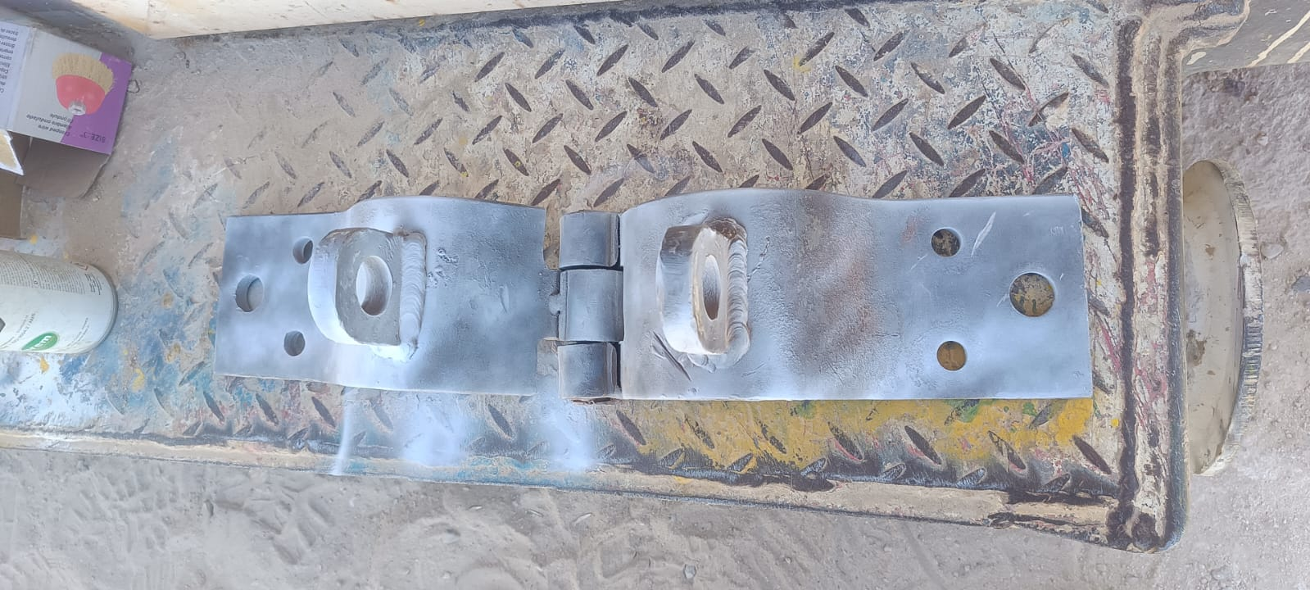
Reference Standard: |  |  | LEEA DOC 048:2015
Is this the first examination after Installation or assembly at a new site or location? |  |  |  |  |  |  |  |  | Was the examination carried out:  Within an interval of 6 months?  With an interval of 12 months?  In accordance with an examination scheme?  After the occurrence of exceptional circumstances?
 |  |  |  | YES |  | NO |  | √ |  |  |  |  |  |  |  | YES |  | √ |  | NO
 |  |  |  |  |  |  |  |  |  |  |  |  |  |  |  | YES |  |  |  | NO |  | √
If the answer to the above question is YES has the equipment been installed correctly? |  |  |  | YES |  | NO |  |  |  |  |  |  |  |  |  | YES |  | √ |  | NO
 |  |  |  |  |  |  |  |  |  |  |  |  |  |  |  | YES |  |  |  | NO |  | √
Identification of any part found to have a defect which is or could not become a danger to persons and a description of the defect: (If none Sate NONE) NONE
Is the above a defect which is of immediate danger to persons: |  |  |  |  |  |  |  |  |  |  |  |  |  |  | YES |  |  |  | NO
Is the above a defect which is not yet but could become a danger to persons  (If YES state the date by when) |  |  |  |  |  |  |  |  |  |  |  | N/A
Particulars of any repair, renewal or alteration required to remedy the defect identified above: NONE
IS THIS EQUIPMENT SAFE TO OPERATE? |  |  |  |  |  |  |  |  |  |  |  |  |  |  | YES | √ |  |  | NO
NDT Equipment Details
Standard |  | ASTM E709 |  |  |  |  | Viewing Condition: |  |  |  | Colored Media |  |  | Method |  |  | WET
Yoke |  | AC |  |  |  |  | Serial No: |  |  |  | 201504044 |  |  | Due Date |  |  | 04-07-2024
Vernier Caliper |  | Digital |  |  |  |  | Serial No: |  |  |  | 8914 |  |  | Due Date |  |  | 04-07-2024
White Contrast |  | FLUXO: WCP-4 |  |  |  |  | Batch No: |  |  |  | L230523/1 |  |  | Due Date |  |  | 23-05-2028
Black Ink |  | FLUXO: Black magnetic ink-3 |  |  |  |  | Batch No: |  |  |  | L230125/3 |  |  | Due Date |  |  | 25-1-2025
NDT Results
Visual and MPI carried out for the above description and found free of surface defects at the time of inspection
Identification of any part found to have a defect and a description of the defect: NONE
Particulars of any repair, renewal or alteration required to remedy the defect identified above: NONE

Name of Inspector: | Name of person authenticating this report: | 
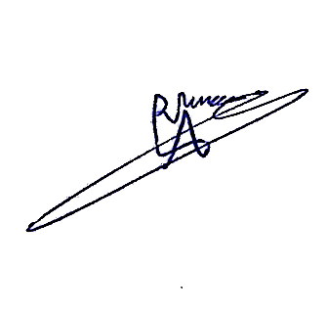  Aram Dlawar | Hasan Omran
 | Signature& Stamp:
Latest date by which next thorough examination must be carried out:05-12-2024

