Client Name: | HILONG OIL SERVICE AND ENG CO, Iraq | Date of Examination: | 06-06-2024
Location of Examination: | HL 99 – RU-258 | Date of Certificate: | 06-06-2024
Certificate Number: | ATS-05-24-3200-159 | Last Examination Date: | -
Job Number: | ATS-05-24-3200 | Next Date of Examination: | 05-12-2024

Serial No: / Asset No: | Description of The Equipment |  |  |  |  |  |  |  |  |  |  | Qty: |  |  | SWL:
301466 | FALL ARRESTER  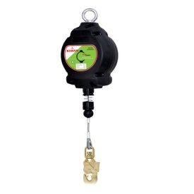  Manufacture: PROTECTA  Manufacture Date: 20/SEP  LOT: 20093846  MODEL: 3590699  Wire Length: 30 M  Location: RIG FLOOR |  |  |  |  |  |  |  |  |  |  | 01 |  |  | 140 KGS
Reference Standards | BS EN 360:2002 / BS EN 363:2018
Is this the first examination after installation or assembly at a new site or location? |  |  |  |  |  |  | Was the examination carried out?
 |  | YES |  |  | NO | √ | Within an interval of 6 months? |  |  |  | YES |  |  | √ |  |  | NO
 |  |  |  |  |  |  | Within an interval of 12 months? |  |  |  | YES |  |  |  |  |  | NO |  | √
If the answer to the above question is YES has the equipment been installed correctly? |  | YES | √ |  | NO |  | In accordance with an examination scheme? |  |  |  | YES |  |  | √ |  |  | NO
 |  |  |  |  |  |  | After the occurrence of exceptional circumstances? |  |  |  | YES |  |  |  |  |  | NO |  | √
Identification of any part found to have a defect which is or could become a danger to persons and a description of the defect: None
Is the above a defect which is of immediate danger to persons |  |  |  |  |  |  |  |  |  |  | YES |  |  |  |  | NO |  |  | √
Is the above a defect which is not yet but could become a danger to persons |  |  |  |  |  |  |  | YES by
Is this Equipment Fit for Purpose? |  |  |  |  |  |  |  |  |  | YES |  |  | √ |  | NO
Particulars of any repair, renewal or alteration required to remedy the defect identified above: None
Particulars of any tests carried out as part of the examination:
Items mentioned-above was inspected Visually and Dimensionally at the time of inspection
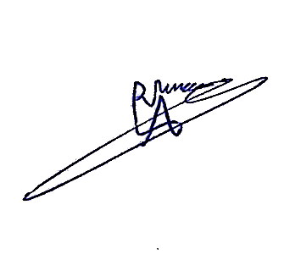  Inspector Name, Qualifications & signature:  Aram Dlawar  ASNT LEVEL II (VT, MT, PT, UT)  LEEA Registered Technician |  |  |  | Authenticated By:  Hasan Omran |  |  |  |  | 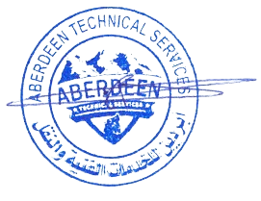  Stamp and Date:
THIS IS TO CERTIFY THAT: a competent person did attend the above-mentioned owner’s work location on the date shown above and the equipment described in this report has been Thoroughly Examined as per the requirements of Lifting Operations Lifting Equipment Regulation “LOLER”. The result was found Satisfactory at the time of Inspection and considered Safe for Lifting.
ATS-LIF-F-002 ISSUE 3 - MAR 2021

