Client: |  | Hilong Oil Services & Engineering |  | Certificate Number: |  | ATS-05-24-3200- MPI-147
Rig Number: |  | HL99 |  | Job No: |  | ATS-05-24-3200
Location: |  | Southern Rumila – RU-258 |  | Page No: |  | 01 of 01
Date of Inspection: |  | 06-06-2024 |  | Next Inspection Date: |  | 05-12-2024
Type of Inspection |  | Visual inspection & MPI (Wet Visible Method) |  | Ref. Standards: |  | ASTM E709, ASTM E 1444
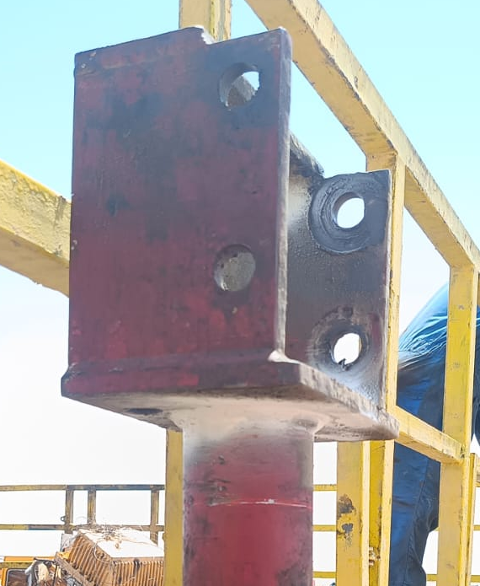  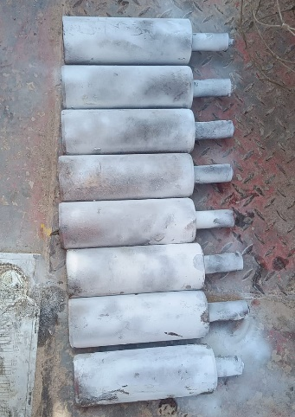  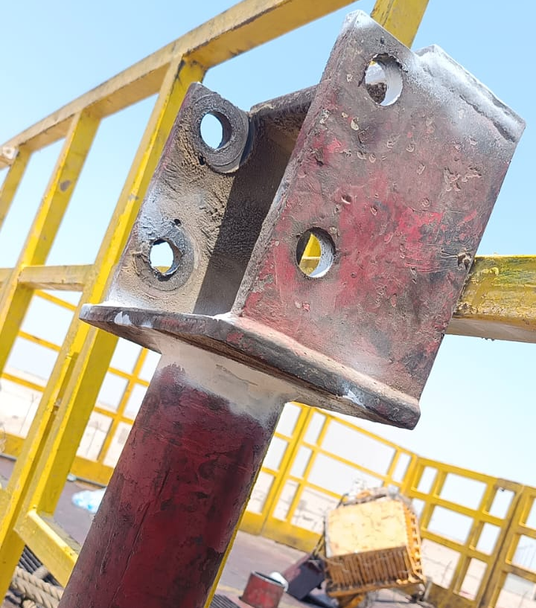  PICTORIAL: |  |  |  |  |  | Item Description: cat head
Unit Serial Number:
CAT1 + CAT2
Details of inspection method(s):
Visible magnetic particle inspection
Inspection Results:
MPI WAS CARRIED OUT ON THE CRITICAL AND WELDING AREAS OF THE ABOVE-MENTIONED ITEMS AND FOUND NO CRACKS OR RELEVANT INDICATIONS AT THE TIME OF INSPECTION.
 |  |  |  |  |  | Remarks: ACCEPTED
Inspection Equipment Details |  |  |  | Personnel Details |  |  | Company Stamp
Equipment | Ac yoke |  |  | Inspector: | Aram Dlawar |  | 
Serial Number | 201504044 |  |  | Qualifications | ASNT LEVEL II
Calibration Date: | 05-01-2024 |  |  | Date: | 06-06-2024
Calibration Due: | 04-07-2024 |  |  | Signature: | 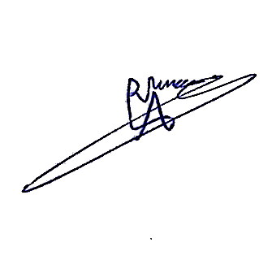
Consumables | MAGNETIC PARTICLES INSPECTION |  |  | Signature:
Maker and Model | FLUXO |  | FLUXO | Supervisor: | Hasan Omran
Type: | WCP-4 |  | Black magnetic ink-3 | Supervisor:
Batch Number | L230523/1 |  | L230125/3 | Date: | 08-06-2024
Expiry Date: | 23-05-2028 |  | 25-1-2025 | Date:

